Subject: We’re Half-Way with United Way

Hello [Employee Name],

We are well into our United Way campaign and we are off to a strong start! If you’ve already given--thank you. Our campaign runs through [End Date], and with your generous support, we
can reach our [$] goal.

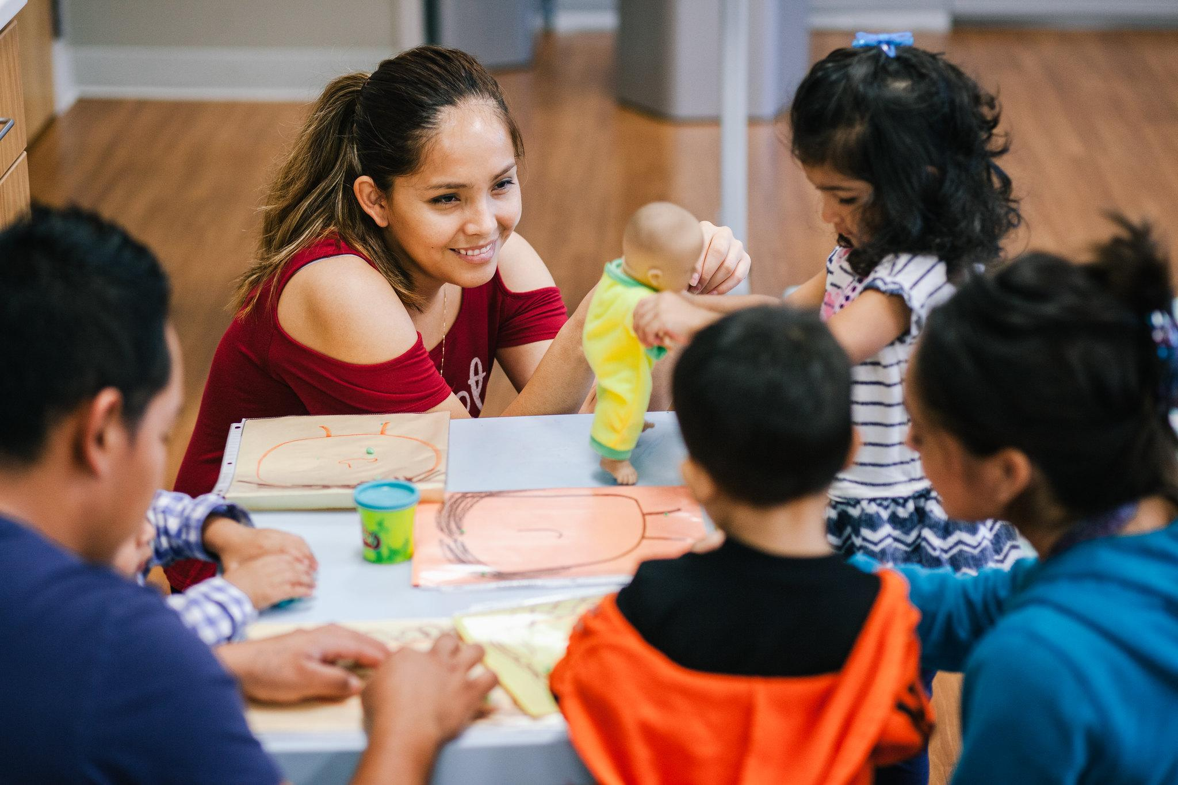
There is still time for you to make a real, lasting impact in our community.

In 2018, donors like you made this big impact possible:
- $7,000,000+ invested directly into our community
- 390,389 calls for assistance answered through our 2-1-1 helpline and Navigation Center
- 47,677 children and families impacted
(link this button to your donation portal)

Thanks to the generosity of people like you, [Company Name] and United Way are changing our community for the better. Please help us finish strong by making a gift today (link this text to your donation portal).

[Company Sender Name]
[Title], [Company]

